ITECH1502 Final Project Report- TryHackMe’s Vulnversity
Student ID: 30502249
Student Name: Ish Chander
Platform Chosen: TryHackMe – Vulnversity room
tryhackme.com/room/vulnversity
Portfolio: [https://github.com/IshC123/Cybersecurity-Portfolio.git]
Summary: This project documents a web application penetration test of the Vulnversity machine on TryHackMe, which I have completed for the final exam of ITECH1502. TryHackMe is a browser-based platform that provides you with guided rooms and live virtual machines so you can practice security techniques legally on real systems. So, my goal was to work from an attacker’s viewpoint. I proceeded through the standard phases of a penetration test. Reconnaissance with Nmap revealed six open ports and an Apache web server on the unusual port 3333. Directory enumeration with Gobuster showed a hidden /internal upload page. By fuzzing the upload form’s file type filter in Burp Suite intruder, I managed to find out that the .phtml extension bypassed the block list while also still executing as PHP. Then I used it to upload a reverse shell, making me gain a foothold as the www-data user and capturing the user flag. Then finally I managed to exploit a misconfigured SUID permission on /bin/systemctl to escalate to root and read the root flag, which in turn completed the room when I answered the question. This room taught me how a small thing like an insecure file upload and weak permission configuration can be chained together into a full system compromise, and what controls prevent that.
Introduction: The platform. TryHackMe is a browser-based cybersecurity training platform that’s built around guided “rooms” each room has a live virtual machine paired with short lessons and questions that you must answer to finish the room. Learners start by connecting to a target through a browser-based attack box and practice real techniques that are implemented safely & legally. It was highly recommended to me by my previous assignments and its widely used by students and employers to build job ready hands-on skills.
Relevance to Cybersecurity Learning. Vulnversity walks you through a full cycle of a penetration test which is Reconnaissance, enumeration, exploitation and privilege escalation which in turn directly supports the unit outcomes on vulnerability scanning and basic penetration testing and on applying security measures to breach scenarios that are realistic. It also supports the ethical basis of the idea that a tester acts only against systems they are authorised to test.
Why did I choose this. The assessments I was assigned to do strongly encouraged me to use TryHackMe for nearly every hands-on activity so it’s the platform I am most comfortable with and the one I have the most experience with. Within it I chose Vulnversity because it is beginner friendly but also highly realistic. The weaknesses it exploited was an insecure file upload and a misconfigured permission these are very common causes of real-world breaches which made it ideal to demonstrate a complete attack chain rather than just a theory.
Problems / Challenges.
The room Simulates a full attack on a university’s vulnerable web server, broken into 4 challenges:
- Reconnaissance.
Scan the target with Nmap to find which ports are open and what services plus versions are running
- Enumeration.
Use Gobuster to brute force hidden directories and find an upload page that isn’t exposed
- Initial access.
The upload Page does its best to block dangerous files, but the filter is weak. Bypass it to upload a PHP reverse shell and get a foothold on the server.
- Privilege escalation.
As a user with low privileges you must find a program with a misconfigured SUID bit and abuse it to become the root (Administrator) user.
Cybersecurity Context and Relevance: The most common weaknesses behind real-world server compromises are Insecure file upload and weak permission settings. Thinking like an attack by scanning, enumerating and chaining these flaws is how defenders learn to find and close them first. In professional terms this exercise covers the identification and exploitation phases of a penetration test, targeting an OWASP class unrestricted file upload and a Linux privilege escalation through SUID misconfiguration.
Project Goals And Objectives
- Use Nmap to identify the open ports, services and version on the target.
- Use Gobuster to enumerate hidden directories and find the upload page.
- Bypass the upload filter to send a reverse shell and gain an initial foothold.
- Exploit a SUID misconfiguration to go from a normal user to root (administrator)
- Recommend solutions for each vulnerability and consider legal and ethical implications of penetration testing.
Methodology
Step | What I did | Tool | Why? (reasoning)
Set up | I started the target machine and attackbox and took notes of the target IP | TryHackMe AttackBox | Work in an isolated, legal, authorised environment.
Scan ports | I ran the command “nmap -sV MACHINE_IP” it showed me a list of open ports and service versions | Nmap | To find the attack surface because known versions have their own weakness that I can exploit.
Enumerate web | Ran Gobuster against the web port with a wordlist so I could find the hidden directories | Gobuster | Upload pages and admin panels are often unlinked but reachable.
Inspect upload | Opened the upload page and tested which file types it accepted | Browser | To try to understand the filter before I try bypassing it.
Bypass filter | Found an allowed file extension (which was phtml) that still ran as PHP also prepared a reverse shell | Burp Suite/Manual | Weak allow lists can be bypassed with an extension that’s less obvious.
Get a shell | I started a Netcat listener that uploaded and triggered the shell | Netcat | Using a reverse shell to connect the target back to me for access
Find the user flag | I explored the file system as the web user | Linux shell | Locates where the first flag is and confirms the foothold
Escalate | Listed SUID binaries and exploited the misconfigured one to run as root | “find”, [the SUID binary] | A SUID program runs with its owner’s rights. When misused it grants root.
Capture root flag | Read the root flag to show full compromise | Linux shell | Demonstrates complete control of the host.
As much as the steps look flawless not every step went smoothly, and the troubleshooting was part of my learning process. Burp Suite’s bult in browser wouldn’t launch on the attack box so instead I managed to configure Firefox to route its traffic through Burp’s proxy on 127.0.0.1:8080 instead. The lab also timed out between sessions since I was using the free trial, which meant I had to repeat the reconnaissance and enumeration stages with new IP addresses every time it timed out. (Later I had to purchase the premium one to continue interrupted.) On my first attempt at the reverse shell the connection timed out because the payload was triggered before the Netcat listener was ready what I later realised was I had to start the listener first. Working through these issues were tough but showed the importance of understanding why each step works rather than just following commands.
Results & The Outcomes / Key findings
Findings | Results | Evidence provided
Open ports and services | FTP (21), SSH (22), Samba (139,445) Squid proxy (3128), HTTP (3333) | Fig 2
Web server | Apache httpd 2.4.41 on port 3333 | Fig 2
Hidden upload directory | /internal | Fig 3
Extension that bypassed the filter | .phtml (response length 759 vs 773) | Fig 4
Initial shell | www-data | Fig 5
User flag | 8bd7992fbe8a6ad22a63361004cfcedb | Fig 5
User who managed the server | bill | Fig 5
SUID binary abused | /bin/systemctl | Fig 6
Root flag | a58ff8579f0a9270368d33a9966c7fd5 | Fig 6
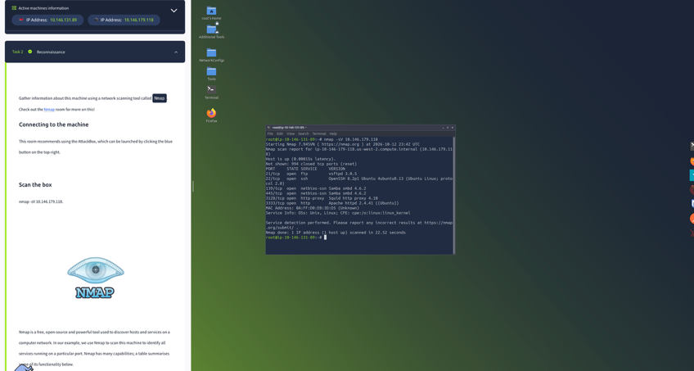
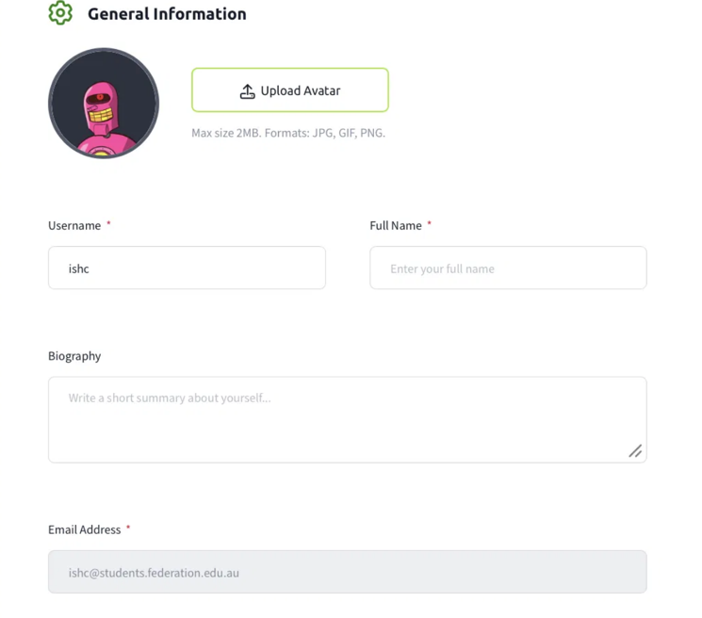
Fig 1: TryHackMe account registered with FedUni student email
Fig 2: Nmap scan showing six open ports and Apache on 3333

Note: Screenshots have been sized down and scaled to fit the page to adhere to the 5-page limit. Zoom in to view each terminal output and command details clearly. Full-resolution images are available on my GitHub portfolio.

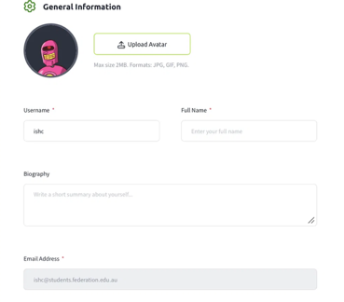
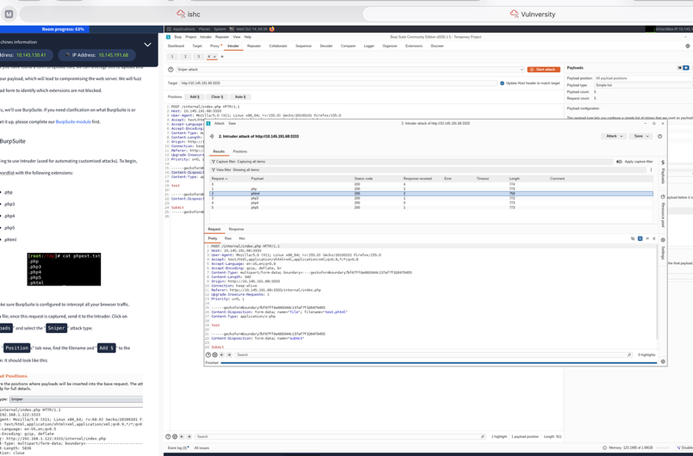
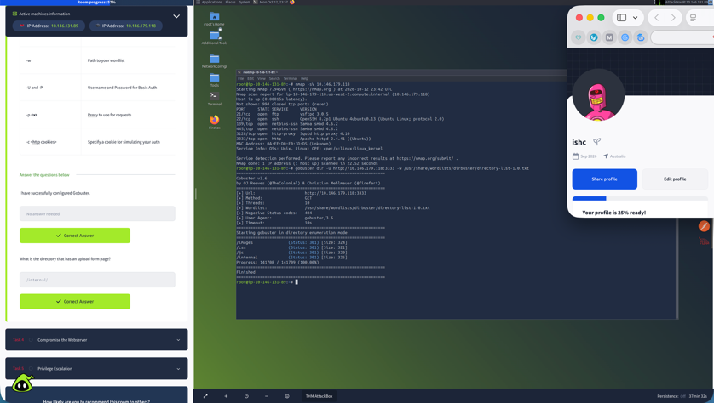
Fig 4: Burp Suite brute forcing the upload filter (.phtml bypass)
Fig 3: Gobuster revealing the hidden /internal upload page
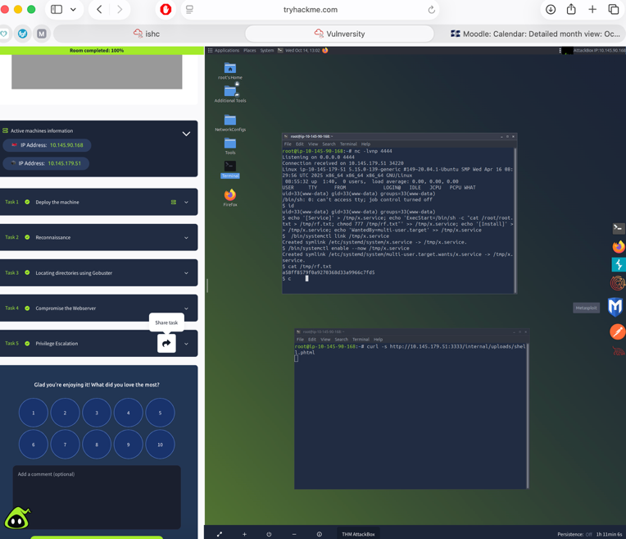
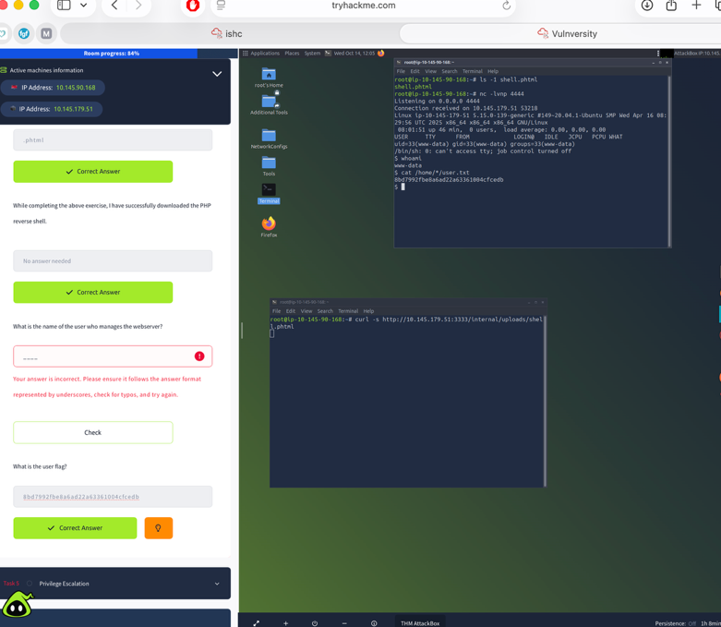
Fig 5: Netcat reverse shell as www-data, retrieving the user flag

Fig 6: Exploiting /bin/systemctl to gain root and then finally read the root flag to complete the activity + Bonus 100% Room complete

Results
All together these findings form a single attack chain: the exposed web server on port 3333 led to a hidden /internal page, the weak filter let a .phtml reverse shell run as www-data then the misconfigured SUID bit on /bin/systemctl then let that account run a service as root and read the root flag a full compromise from one exposed web form.
Mitigation
Weakness exploited | Control that would help
Hidden upload page reachable | Perhaps remove any unused pages and make them require authentication
A weak file-type filter | Validate uploads by content, use a strict allow list, store them outside the web root and non-executable
Reverse shell connected out | Filtering and monitoring for any unexpected outbound connections
SUID misconfiguration | Apply least privilege then remove any unneeded SUID bits also audit SUID binaries regularly

Legal & Ethical
- Authorisation: Attacking a system is illegal if you have not been granted explicit permission. TryHackMe grants this inside its labs doing the same to a system you don’t own would breach the Criminal Code Act 1995 (Cth)
- Scope: A real penetration test is authorised under a signed agreement defining which systems can be tested on. Any activity outside that agreement is unlawful.
- Disclosure & data: findings or any vulnerabilities should be reported privately to the owner any personal data found must never be viewed copied or shared. (Privacy Act 1988)
Reflection.
What I learned. The clearest lesson I learnt was how small individual minor weaknesses chain together into a total compromise. A filter that missed .phtml plus one misconfigured SUID bit took me from an anonymous visitor all the way to root access. I managed to identify the .phtml bypass from just a difference in response length which taught me to keep my eyes sharpened for subtle indicators, and abusing systemctl to escalate made the value of least privilege real rather than theoretical.
Growth. Every skill in this room relates directly to what SOC analysts and penetration testers do daily such as scanning with Nmap, enumerating a web server, testing an upload filter via Burp Suite, and escalating privileges on Linux. Giving me great practical examples that I can use in a future interview. Working through this also grew my confidence in staying on track while time was racing against me it also pushed me to keep heading towards a defensive blue team direction.
What would I do differently? Well if I ran this exact same thing again I would first of all extend the lab time in the first place but unfortunately you can’t extend the attack machine time so maybe I would have bought the subscription first so I would avoid getting cut off mid attack, I would then confirm which host I am actually on before running any commands (I ran escalations steps on my own attack box instead of the target), Then use the tab feature on Linux’s command RUN to make my typing easier and without any mistakes next time. The timeouts, crash and Burp to Firefox proxy setup all reduced my time significantly however troubleshooting them taught me more than a flawless run would have.
References
Australian Cyber Security Centre. (n.d.). Essential Eight. https://www.cyber.gov.au
GTFOBins. (n.d). systemctl. https://gtfobins.org/gtfobins/systemctl/
Nmap (n.d.). Nmap: the Network Mapper. https://nmap.org/book/man.html
OWASP. (n.d.). Unrestricted File Upload.
https://community.owasp.org/vulnerabilities/Unrestricted_File_Upload
TryHackMe. (2026). Vulnversity. https://tryhackme.com/room/vulnversity

